August 31, 2014
FOR IMMEDIATE RELEASE

WHY SIBLING STARS LOOK ALIKE:
EARLY, FAST MIXING IN STAR-BIRTH CLOUDS
Early, fast, turbulent mixing of gas within giant molecular clouds—the birthplaces of stars—
means all stars formed from a single cloud bear the same unique chemical “tag” or “DNA fingerprint,”
finds computational astronomers at University of California, Santa Cruz

Could such chemical tags identify our own Sun’s long-lost sibling stars?

Findings published in Nature online August 31, 2014

Stars are made mostly of hydrogen and helium, but they also contain trace amounts of other elements, such as carbon, oxygen, iron, and even more exotic substances. By carefully measuring the wavelengths (colors) of light coming from a star, astronomers can determine how abundant each of these trace elements is. For any two stars at random, the abundances of their trace elements will slightly differ: one star may have a bit more iron, the other a bit more carbon, etc.
However, astronomers have known for more than a decade that any two stars within the same gravitationally bound star cluster always show the same abundances. “The pattern of abundances is like a DNA fingerprint, where all the members of a family share a common set of genes,” said Mark Krumholz, associate professor of astronomy and astrophysics at University of California, Santa Cruz (UCSC).
Being able to measure this “fingerprint” is potentially very useful, because stellar families usually do not stay together. Most stars are born as members of star cluster, but over time they drift apart and migrate across the galaxy. Their abundances, however, are set at birth. Thus, astronomers have long wondered if it might be possible to tell if two stars that are now on opposite sides of the galaxy were born billions of years ago from the same giant molecular cloud. In fact, they further wondered, might it be possible even to find our own Sun’s long-lost siblings?
Just one big problem: “Although stars that are part of the same long-lived star cluster today are chemically identical, we had no good reason to think that such family resemblance would hold true of stars that were born together but then dispersed immediately,” explained Krumholz. “The underlying problem was that we didn’t really know why stars are chemically homogeneous.” For example, in a cloud where stars formed rapidly, might the cloud not have had enough time to homogenize thoroughly, thus giving rise to stars born at the same time but not uniform in chemical composition? “Without a real understanding of the physical mechanism that produces uniformity, everything was at best a speculation,” he added.

Surprising violence
So Krumholz and his graduate student Yi Feng turned to UCSC’s Hyades supercomputer to run a fluid dynamics simulation. They simulated two streams of interstellar gas coming together to form a cloud that, over a few million years, collapsed under its own gravity to make a cluster of stars. “We added tracer dyes to the two streams in the simulations, which let us watch how the gas mixed together during this process,” Krumholz recounted. They put red dye in one stream and blue dye in the other, but by the time the cloud started to collapse and form stars, everything was purple—and the resulting stars were purple as well. “We found that, as the streams came together, they became extremely turbulent, and the turbulence very effectively mixed together the tracer dyes,” he said.
“The simulation revealed exactly why stars that are born together end up having the same trace element abundances: as the cloud that forms them is assembled, it gets thoroughly mixed very fast,” Krumholz said. “This was actually a surprise: I didn’t expect the turbulence to be as violent as it was, and so I didn’t expect the mixing to be as rapid or efficient. I thought we’d get some blue stars and some red stars, instead of getting all purple stars.”
In other runs of the simulation, Krumholz and Feng observed that even clouds that do not turn much of their gas into stars—as the Sun’s parent cloud probably didn’t—still produce stars with nearly-identical abundances. “We’ve provided the missing physical explanation of how and why chemical mixing works, and shown convincingly that the chemical mixing process is very general and rapid even in an environment which did not yield a star cluster, like the one where the Sun must have formed,” said Krumholz.
The finding puts the idea of chemical tagging on much firmer footing. “This is good news for prospects for finding the Sun’s long-lost siblings,” Krumholz stated.
For more information:

The paper “Early turbulent mixing as the origin of chemical homogeneity in open star clusters” is published in the August 31 online issue of Nature. A preprint appears at https://sites.google.com/a/ucsc.edu/krumholz/publications/feng14a.pdf.

The UCSC press release “Mixing in star-forming clouds explains why sibling stars look alike” is at http://news.ucsc.edu/2014/08/star-formation.html (URL will be live on Tuesday, September 2).

This work was supported by the National Science Foundation and the National Aeronautics and Space Administration; the Hyades supercomputer was obtained in part through funding from the University of California High-Performance AstroComputing (UC-HiPACC).

The University of California High-Performance AstroComputing Center (UC-HIPACC), based at the University of California, Santa Cruz, is a consortium of nine University of California campuses and three affiliated Department of Energy laboratories (Lawrence Berkeley Laboratory, Lawrence Livermore Laboratory, and Los Alamos National Laboratory). UC-HiPACC fosters collaborations among researchers at the various sites by offering travel and other grants, co-sponsoring conferences, and drawing attention to the world-class resources for computational astronomy within the University of California system. More information appears at http://hipacc.ucsc.edu.

Illustration, movies, and caption:
The two 11-second movies from the computational simulation can be found on the UC-HiPACC website at http://hipacc.ucsc.edu/PressRelease/sibling-stars_videos.html. They are also available at Mark Krumholz’s website at https://sites.google.com/a/ucsc.edu/krumholz/movies and on individual pages on Vimeo at http://vimeo.com/104368279 and http://vimeo.com/104368278 .

Two alternative still illustrations, both with the face-on movie shown at top and the edge-on movie at the bottom; the same caption can be used for either illustration or the movies:

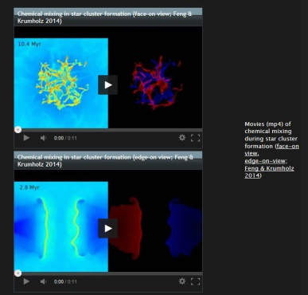
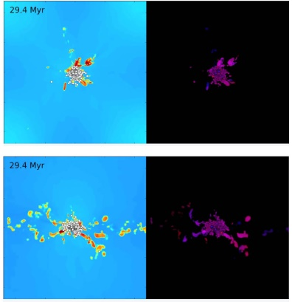

CAPTION: Two 11-second movies shows a computational simulation of a collision of two converging streams of interstellar gas, leading to collapse and formation of a star cluster at the center. In both movies, the numbers rapidly increasing shows the passage of time in millions of years; left panel shows the density of interstellar gas (yellow and red are densest) and right panel shows red and blue “tracer dyes” added to watch how the gas mixes during the collapse. Face-on view (upper pair in the stills) shows the plane where the two gas streams meet while the edge-on view (lower pair in the stills) shows a cross section through the two streams. Circles outlined in black are stars; stars are shown as white in the left panel, and in the right panel their color reflects the amount of the two tracer dyes in each star. The simulation reveals that gas streams are thoroughly homogenized within a very short time of converging, well before stars begin forming. Credit for both stills and movies: Mark Krumholz/University of California, Santa Cruz

For interviews, contact:
Mark Krumholz
Associate Professor, Astronomy & Astrophysics
University of California, Santa Cruz 95064
mkrumhol@ucsc.edu
Ofc: 831-459-1312
Cell: 510-761-2929
[NOTE TO REPORTERS: Dr. Krumholz will be available by cell phone in the U.S. until 6 PM Pacific time Friday, August 29 and again from Thursday afternoon, September 2 until about 6 PM Saturday, September 4. He will be out of the country (Australia) from 6 PM Pacific Friday, August 29 through Thursday afternoon Pacific September 2, and leaving again around 6 PM Pacific Saturday, September 4 for France. During his travels, he can be reached via Skype (username mark krumholz) or Google+ (username for hangouts: mark.krumholz@gmail.com).]
Joel R. Primack, Director
University of California High-Performance AstroComputing Center (UC-HiPACC)
Department of Physics
University of California, Santa Cruz 95064
joel@ucsc.edu
Cell: 831-345-8960

Press release written by:
Trudy E. Bell, M.A.
Senior Writer, UC-HiPACC
t.e.bell@ieee.org or tebell@ucsc.edu

